**Project Deliverable 2 – Documentation and Coding**

**Faculty Name:** Information Technology

**Module Code:** ITECA3-B12

**Module Name:** Web Development and e-Commerce

**Content Writer:** Sandile Dlamini

**Copy Editor:** Mr Kyle Keens

**Submission Date:** Block 2 Week 4

|  |  |
| --- | --- |
| **Student Name** | Tanaka Augustine Zuze |
| **Student Number** | GLLX38ZS3 |
| **Project Title** | Deliverable 2 |
| **Submission Date** | 2024/06/14 |

2

**Table of Contents**

2.1 Introduction 3

2.2 Prototyping 4

2.3 Designing 22

2.4 Coding 26

2.5 Conclusion 33

2.6 Sign-off 33

2.7 Bibliography 35

# Introduction

At the beginning of my academic year, I was tasked with creating an ecommerce site for a project. I did not know that this would put me on a path that would broaden my knowledge in web development. I met a client who I was able to usher into the new age of online transaction. He asked me for the following specifications, a minimalistic design that would translate his creativity, a site that was unique and that was my first step.  
  
I designed a minimalistic site that I worked on with plenty of input from the client. Once he signed off on the design, he then told me he wanted a secure platform where his clients could feel comfortable doing transactions, a working site that would do everything I said it would do efficiently and I was able to deliver on all my client’s specifications

# Prototyping

1. **Prototype 1.**

Main page

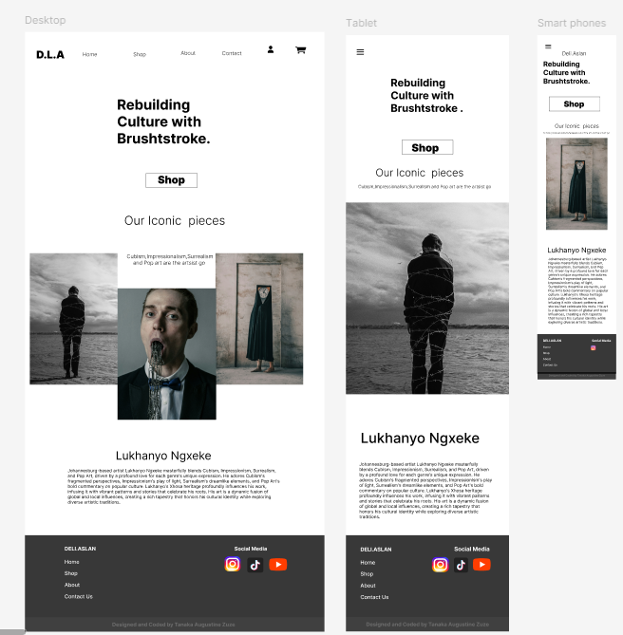

Shopping Page

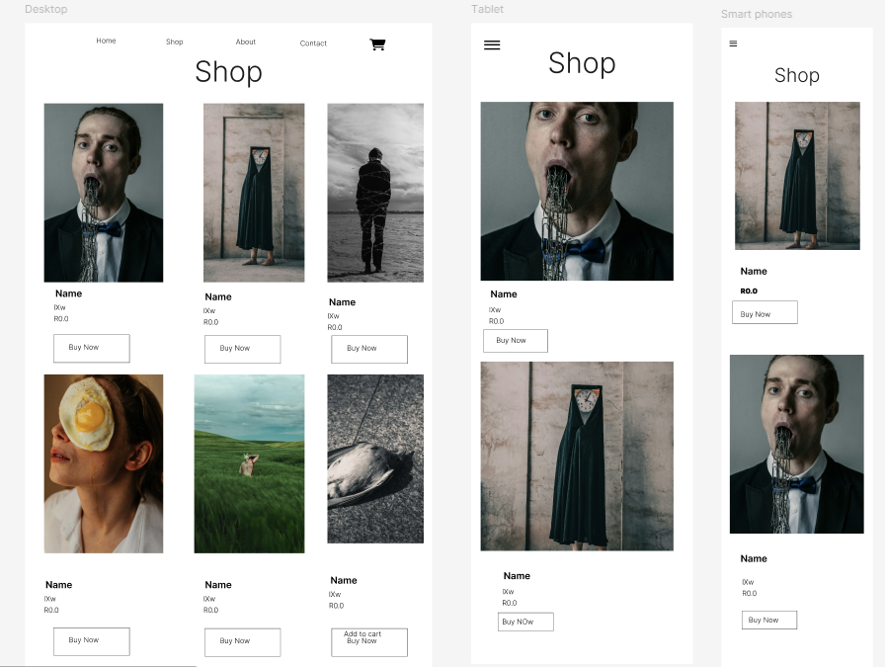

Cart

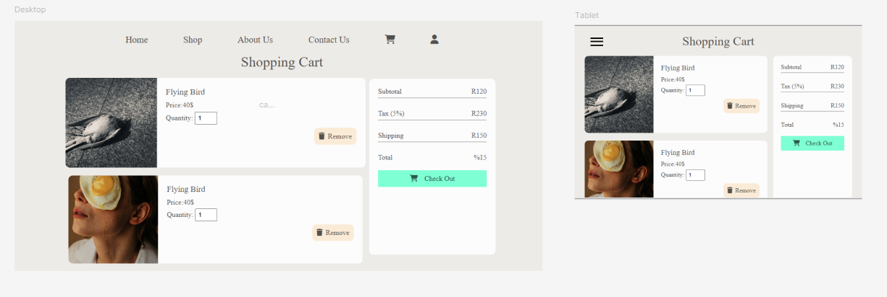

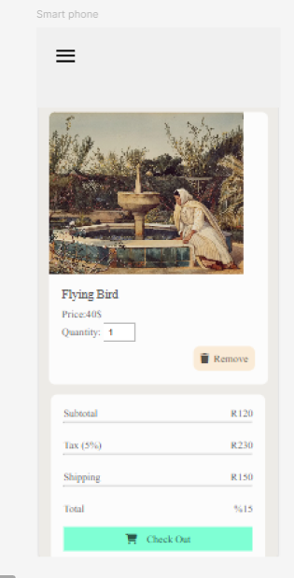

Contact page

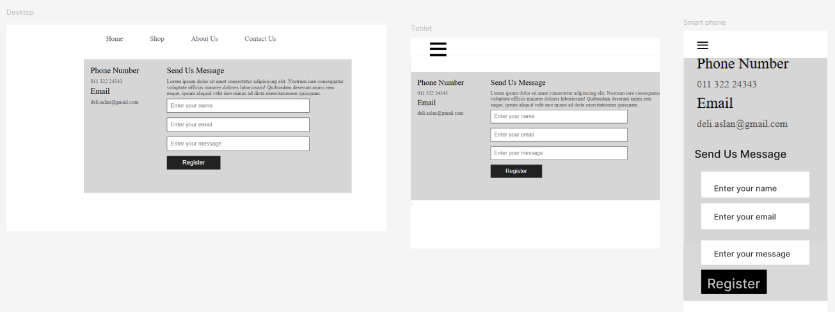

Log in

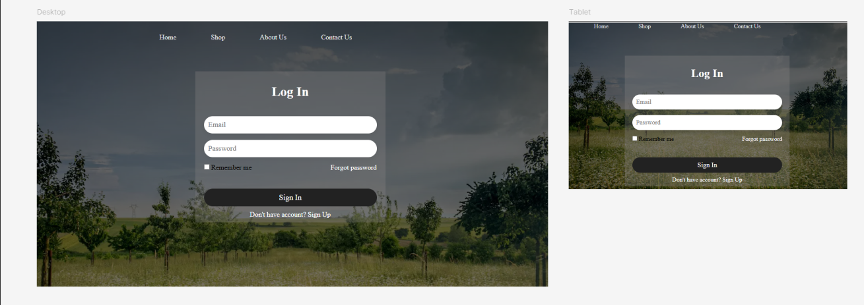

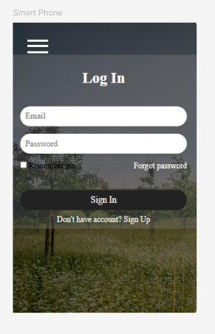

Payment gateway desktop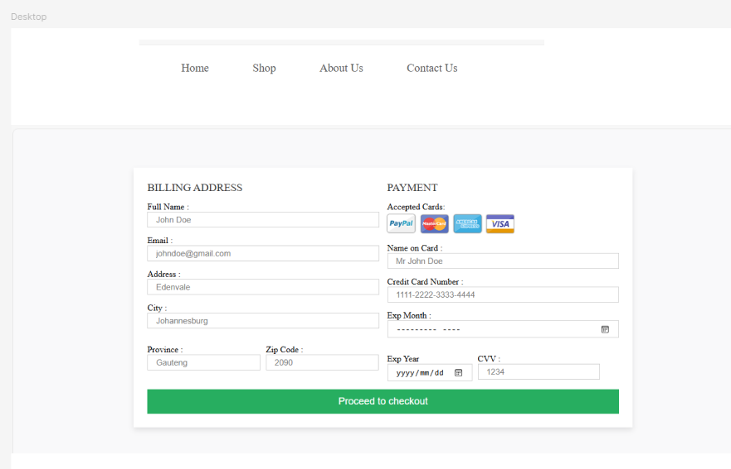Tablet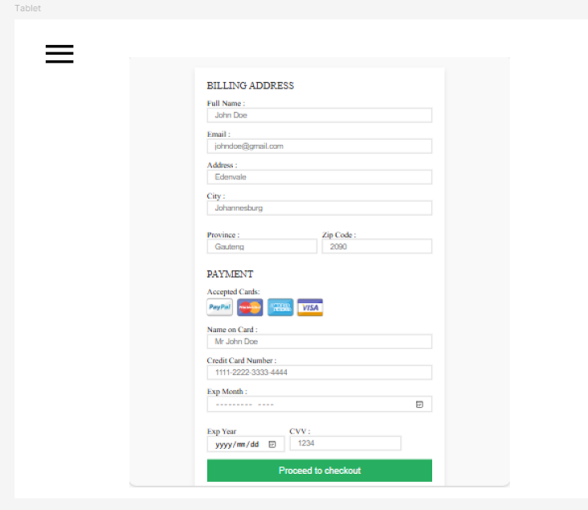

Smart phone

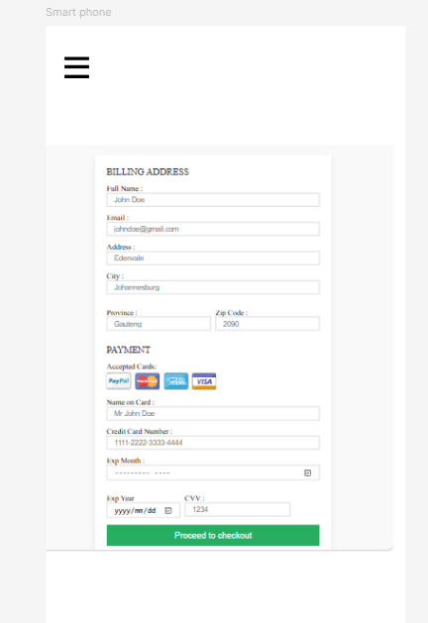

Sign up Desktop

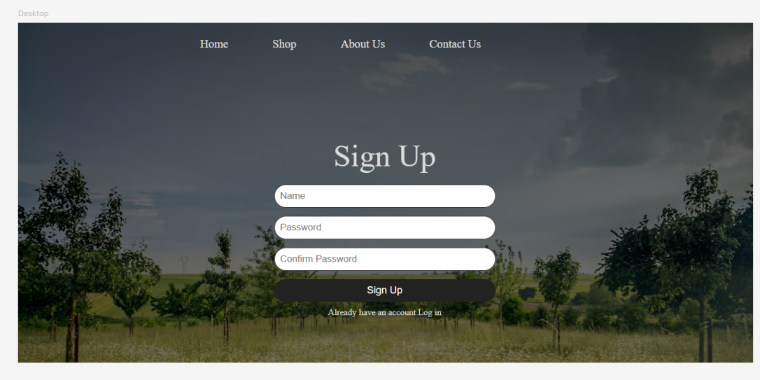

Sign up tablet

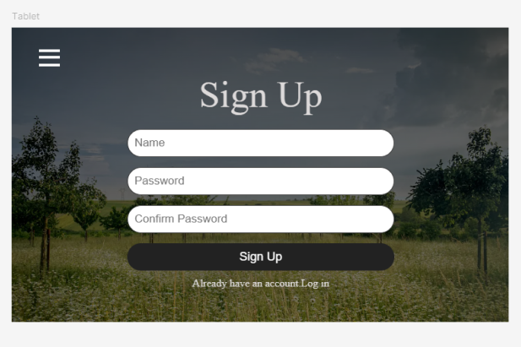

Sign up smart phone



Single product page

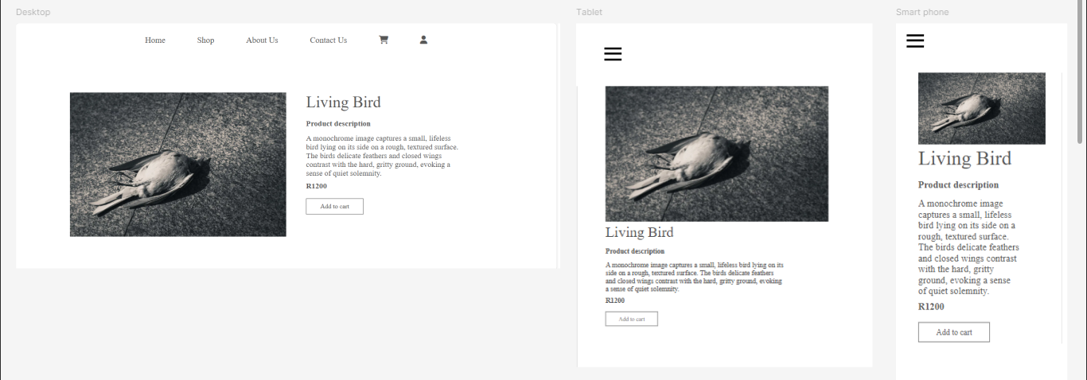

1. **Prototype 2 [The selected prototype]**

Main page

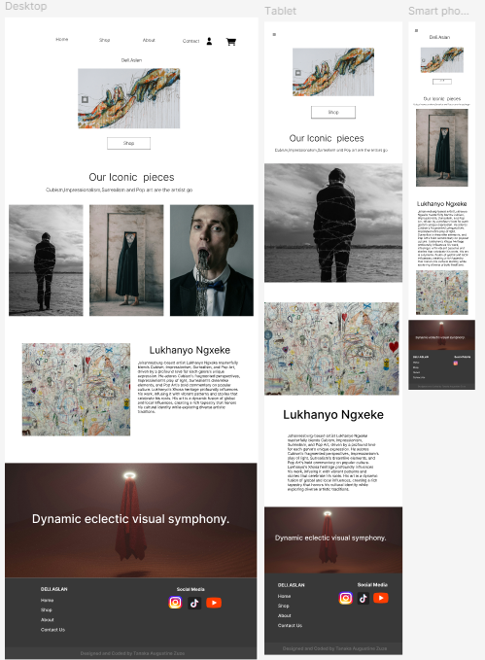

Shopping page

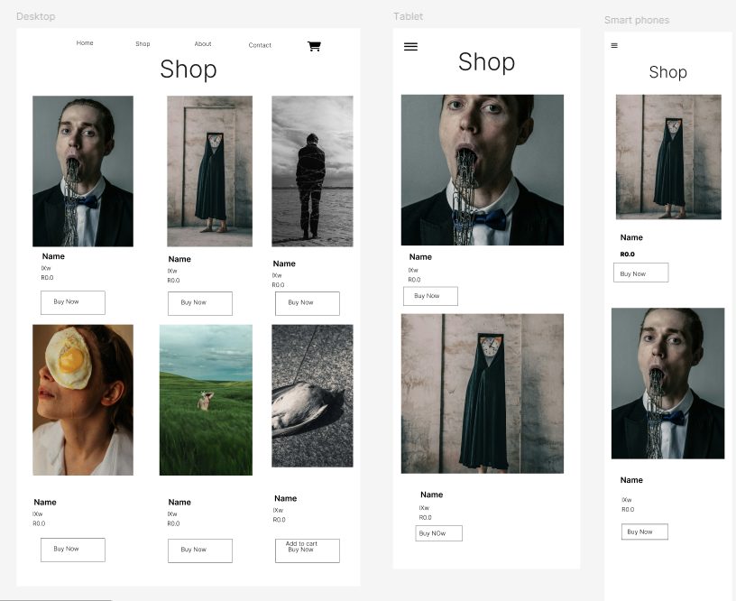

Cart page





Contact page



Log in page





Payment gateway desktop page



Payment gateway tablet page



Payment gateway phone page



Register Desktop page



Register Tablet page



Register page phone

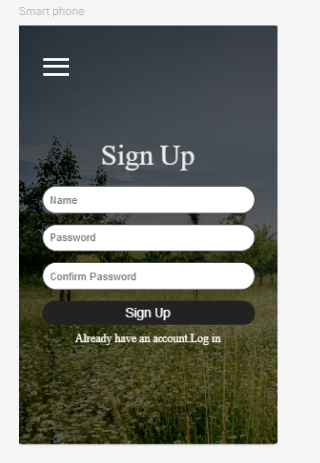

Single product page



# Designing

1. **Class Responsibility Collaborator (CRC) cards**

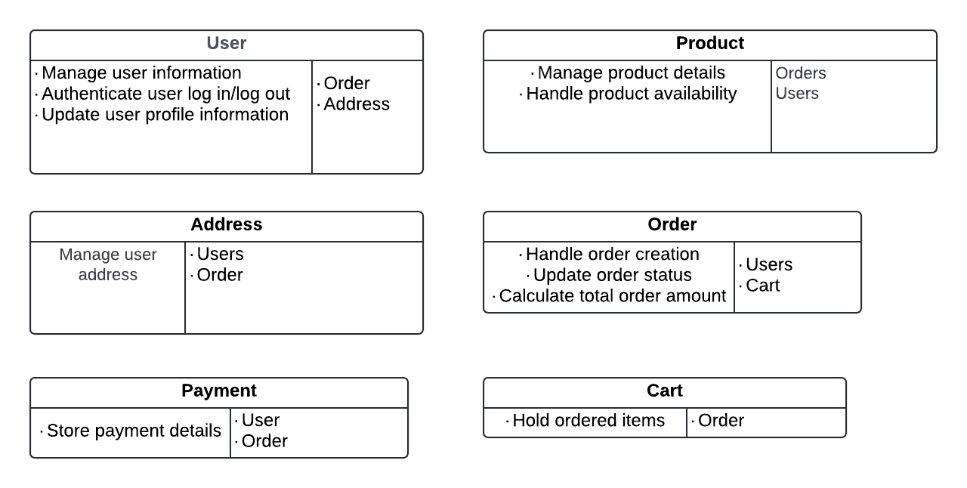

1. **Enhanced Entity Relationship Diagram (EERD)**

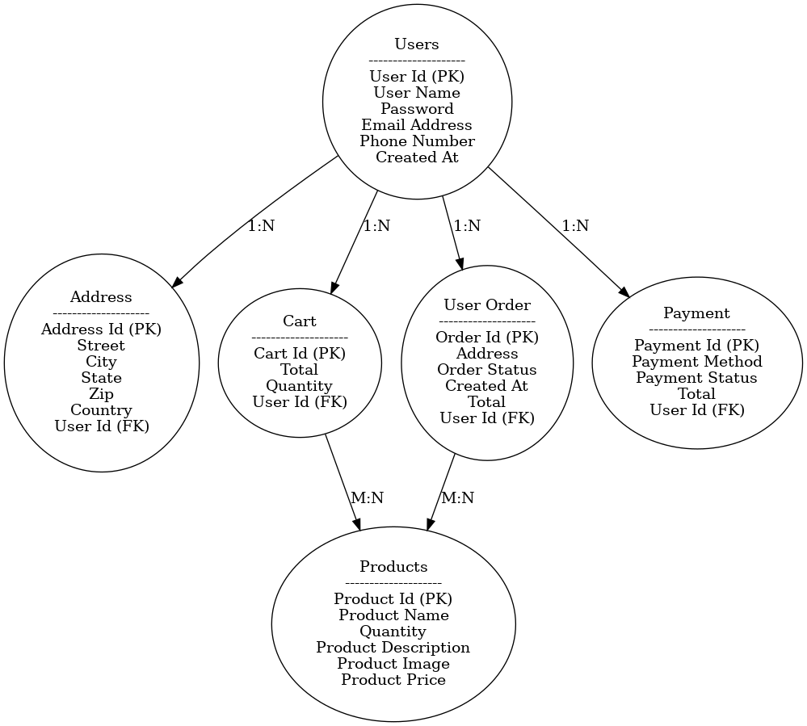

1. **Context Diagram**

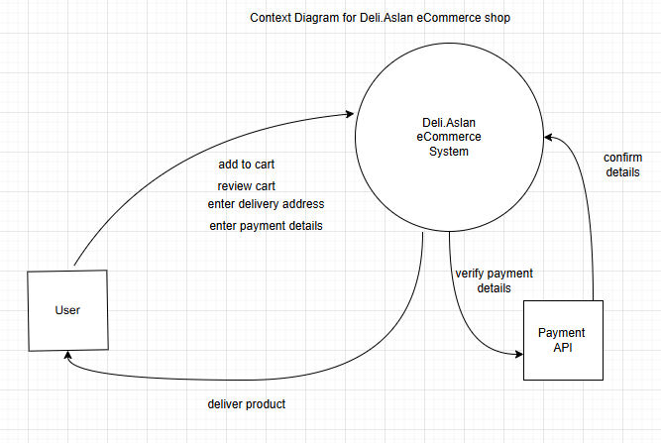

1. **Data Flow Diagram (DFD)**

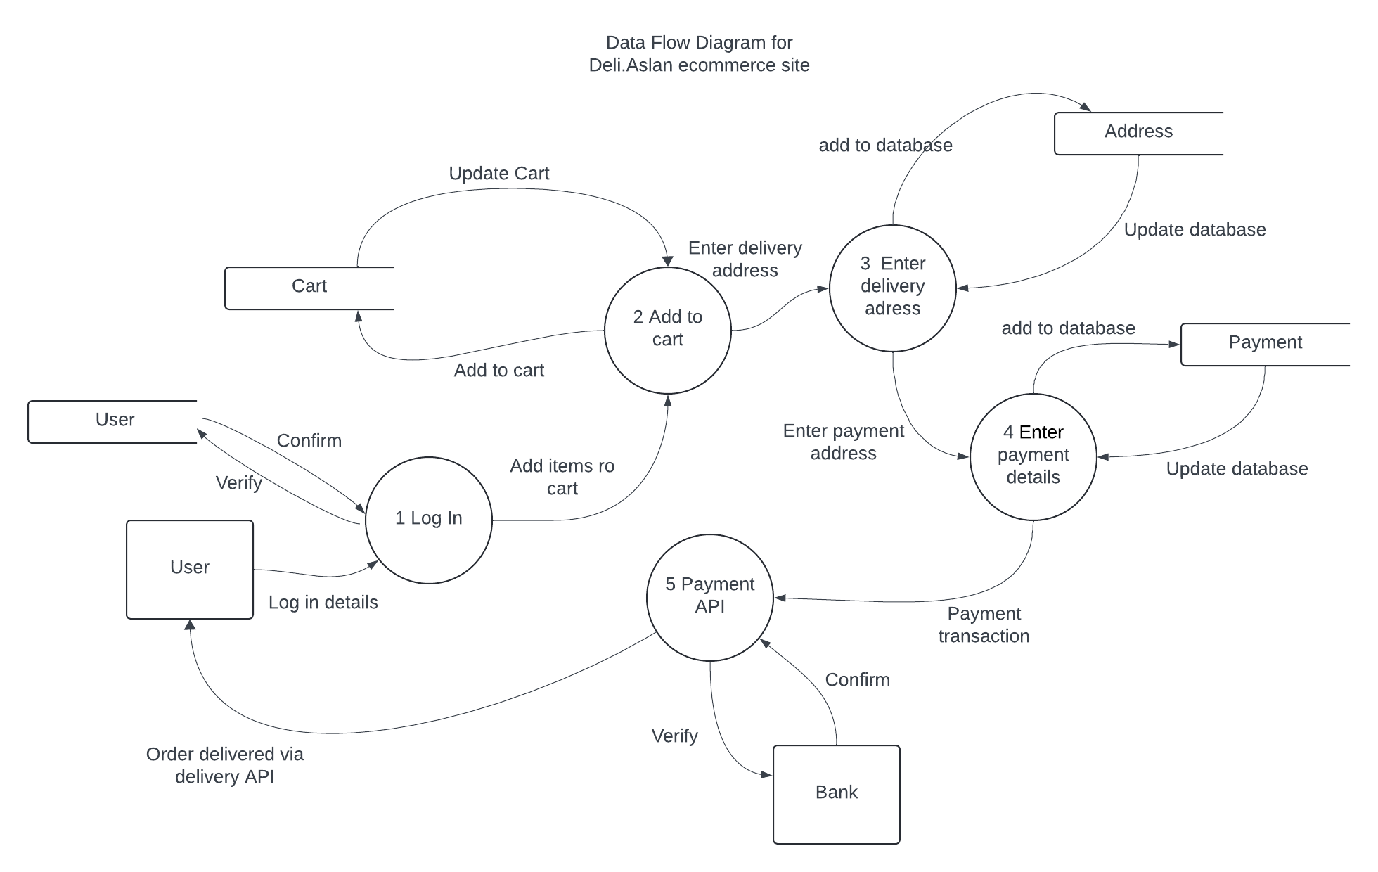

1. **Use Case Diagram**

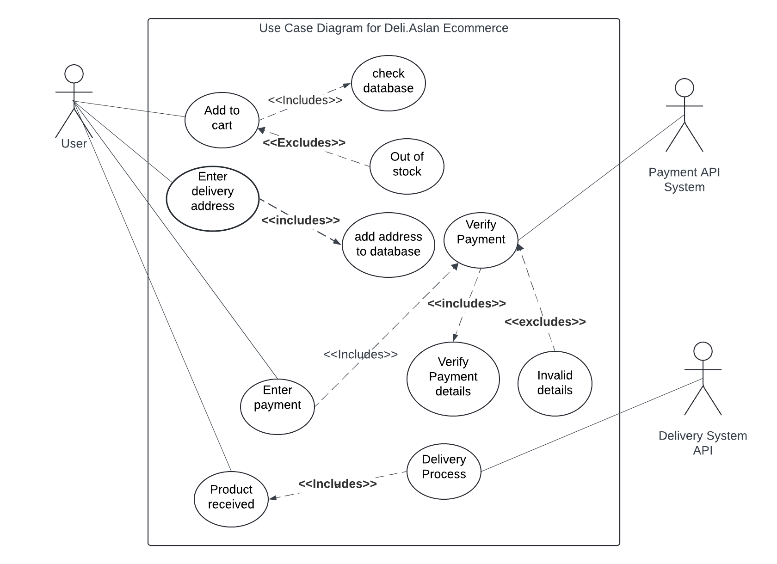

1. **Database Design**

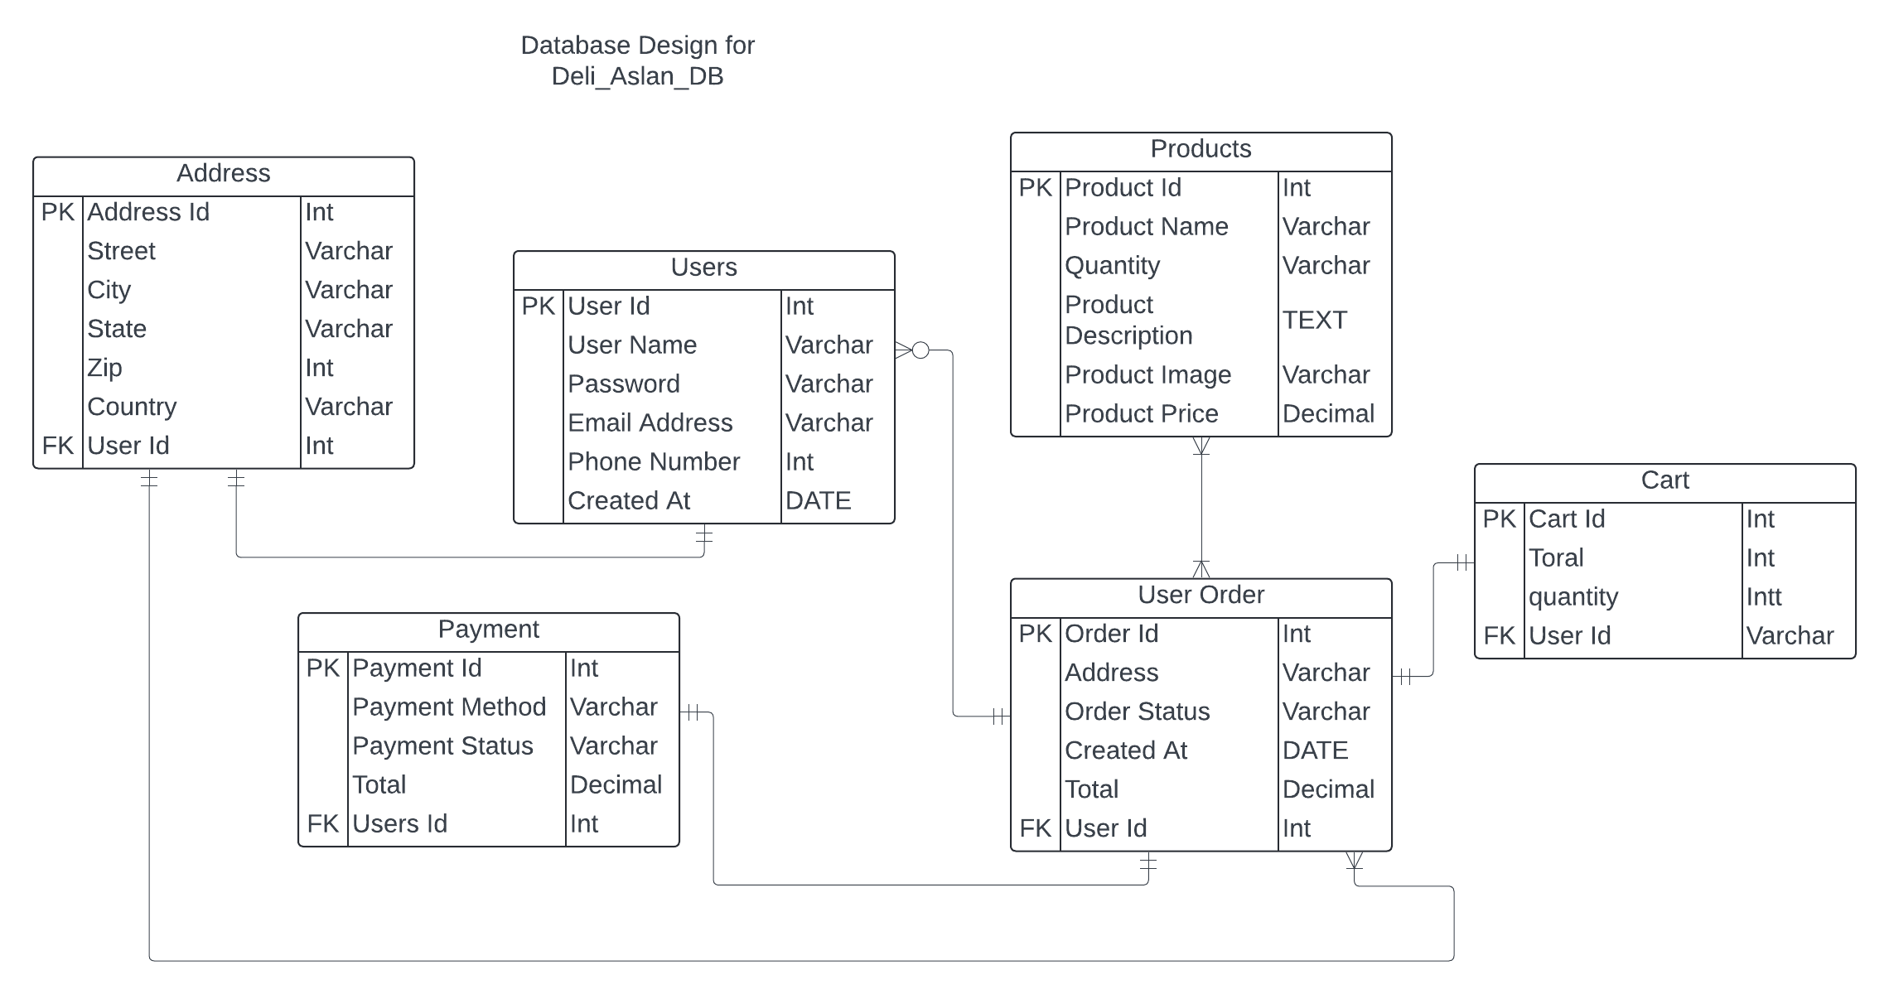

# Coding

1. **Screenshots**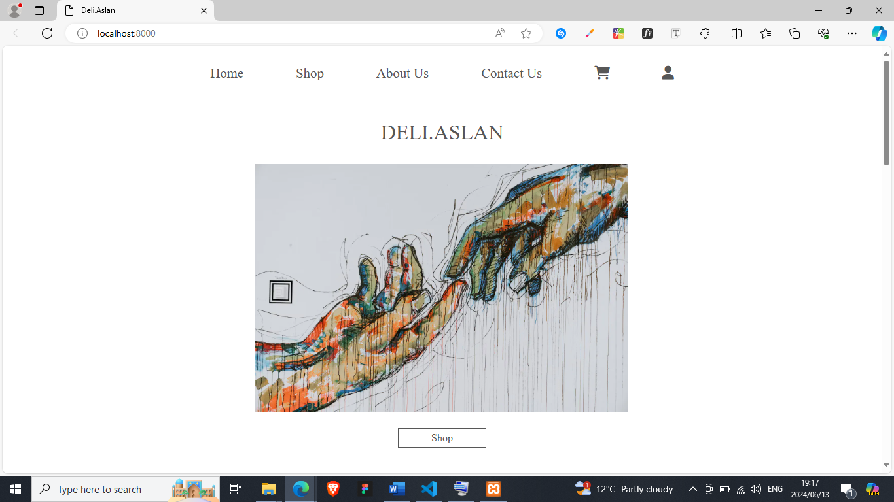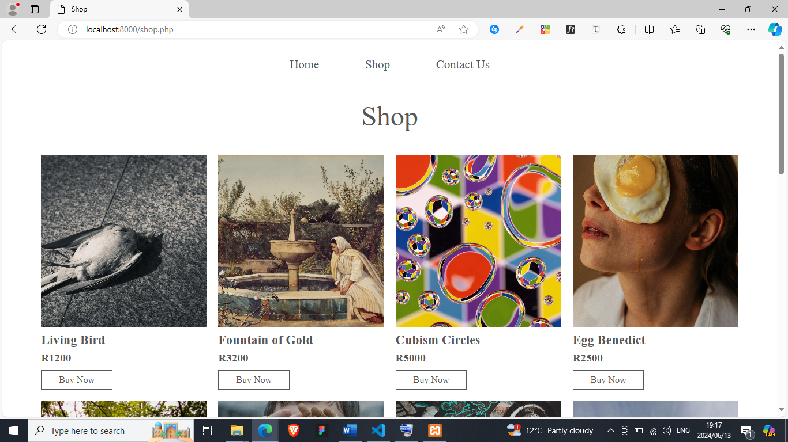

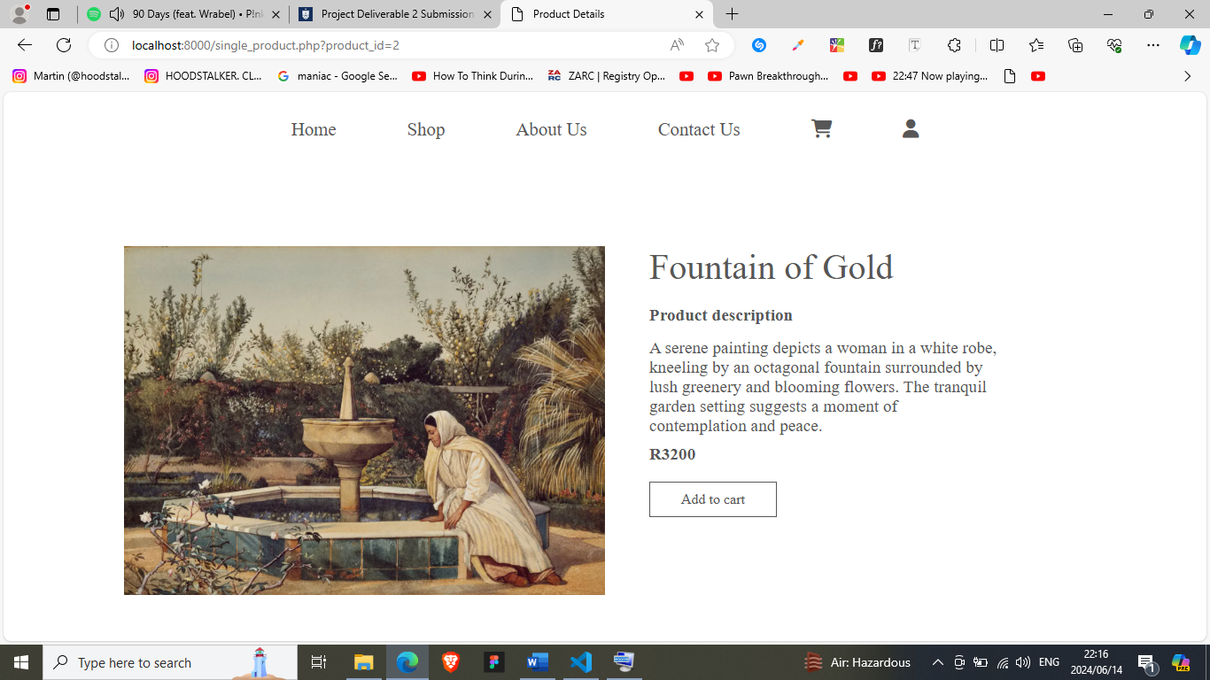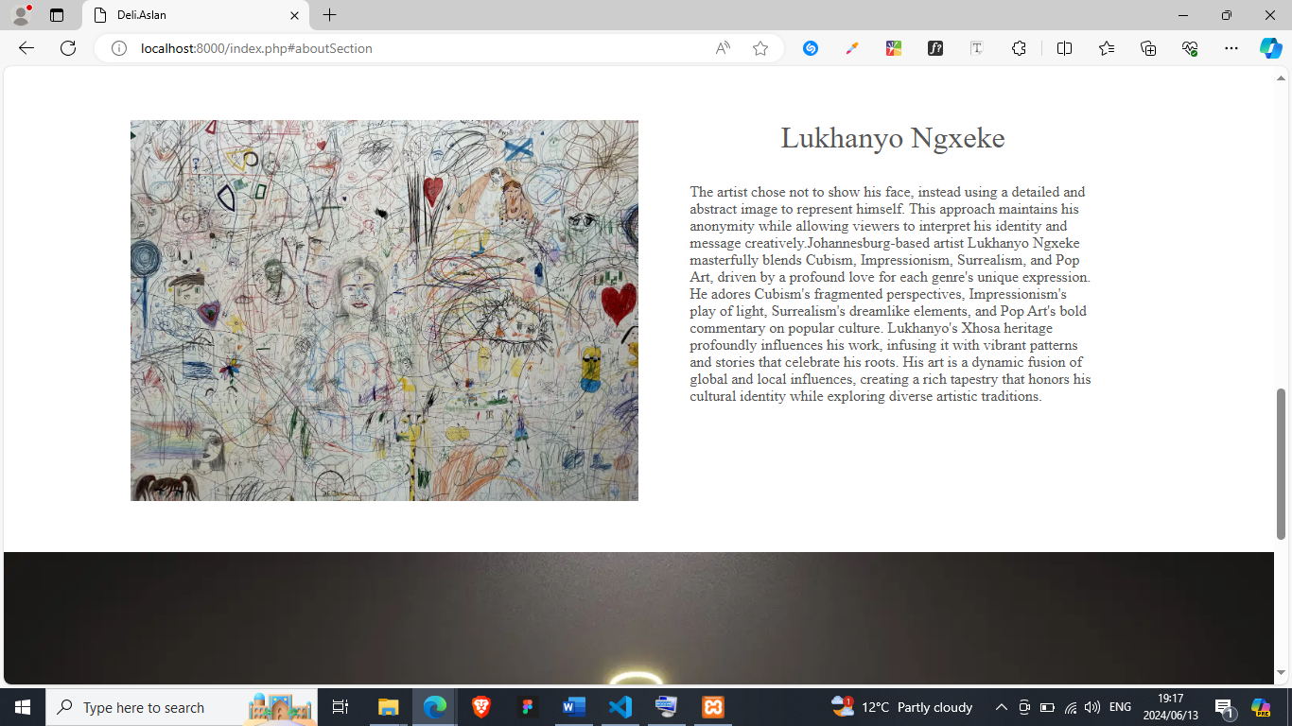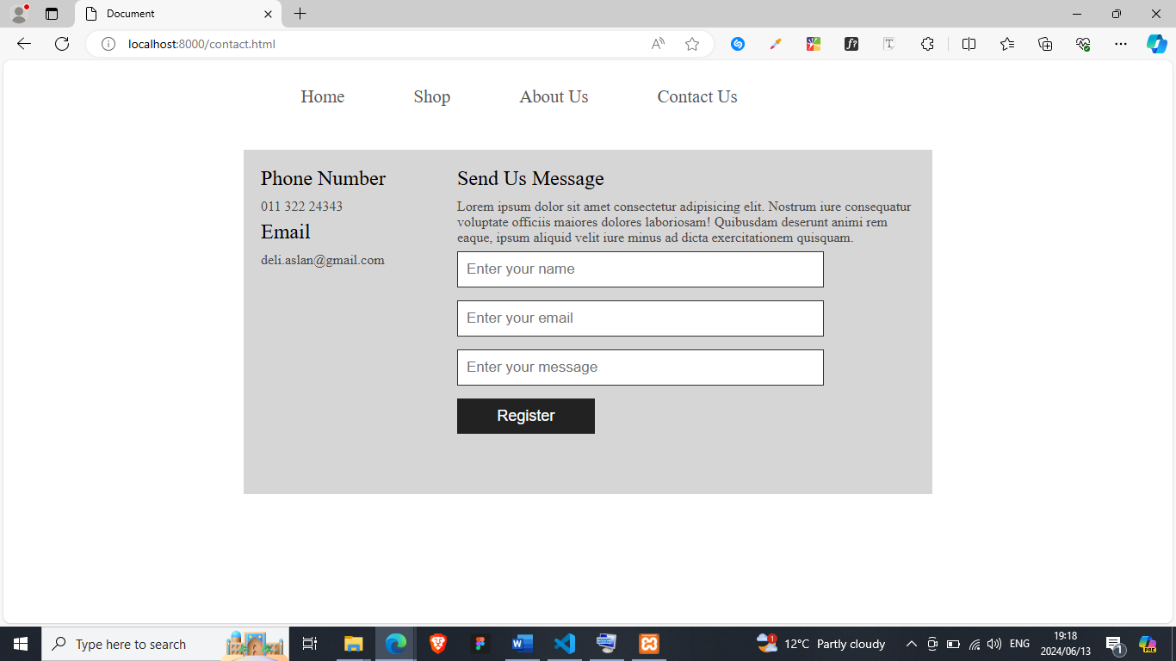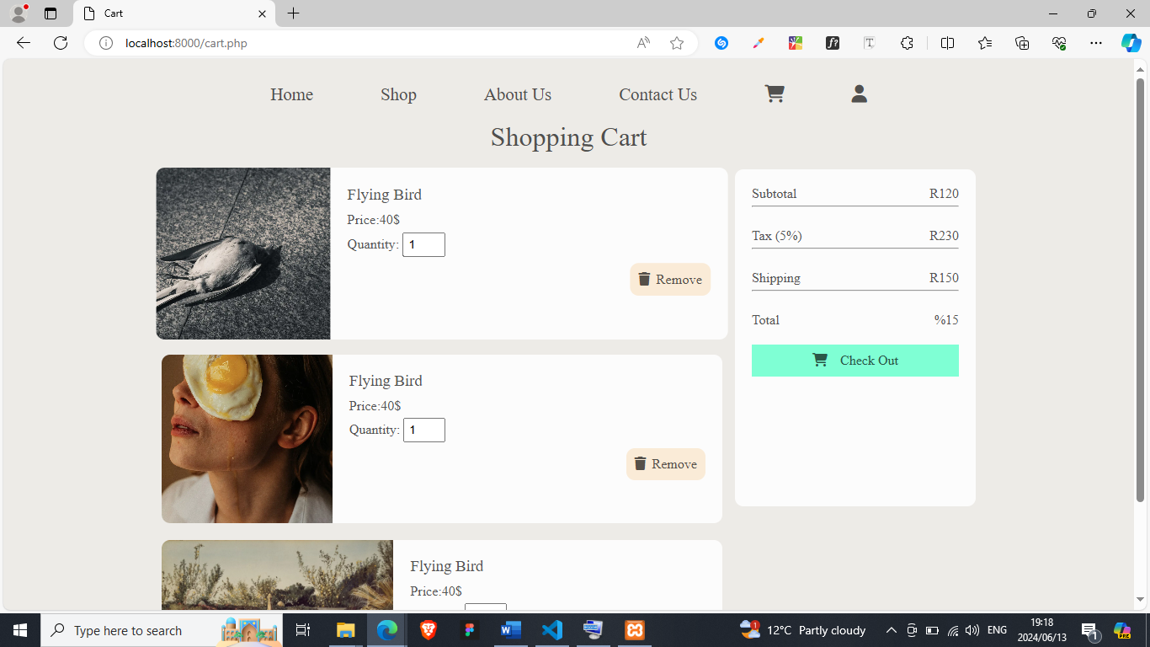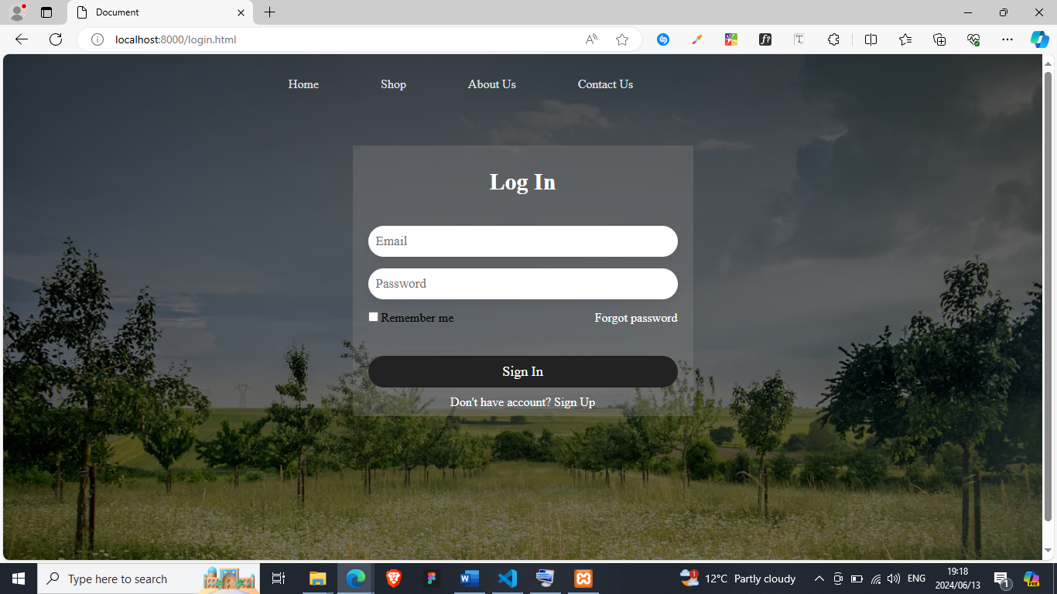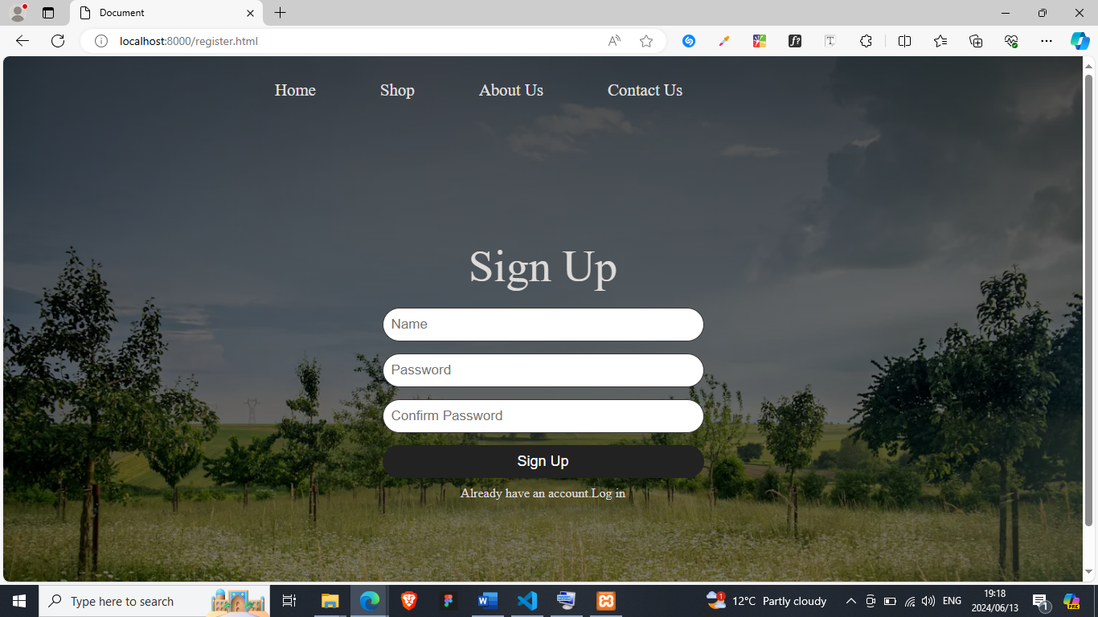

1. **Sample PHP Code**
2. <?php
3. require_once 'assets/server/connection.php';
4. if (isset($_GET['product_id'])) {
5. $product_id = $_GET['product_id'];
6. *// Prepare the SQL statement*
7. $sql = $conn->prepare("SELECT * FROM products WHERE product_id = ?");
9. *// Bind the parameters*
10. $sql->bind_param("i", $product_id);
11. *// Execute the query*
12. $sql->execute();
13. *// Get the result*
14. $result = $sql->get_result();
15. *// Check if the product exists*
16. if ($result->num_rows > 0) {
17. $single_product = $result->fetch_assoc();
18. } else {
19. header('Location: index.php');
20. exit();
21. }
22. } else {
23. header('Location: index.php');
24. exit();
25. }
26. ?>
27. <section id="single-products">
28. <div class="product-img">
29. <img src="assets/img/products/<?php echo $single_product["product_image"]; ?>" alt="">
30. </div>
31. <div class="product-description">
32. <h1><?php echo $single_product["product_name"]; ?></h1>
33. <h3 class="description-header">Product description</h3>
34. <p><?php echo $single_product["product_description"]; ?></p>
35. <h3>R<?php echo $single_product["product_price"] ?></h3>
36. <a href="cart.html">Add to cart</a>
37. </div>
38. </section>

The above code is represented by the shopping page where the php and html are integrated to dynamically generate the products and price from the database instead of hard coding them

1. **Sample HTML Code**

<div class="container">

      <div id="aboutSection">

        <div class="abtImg">

          <img

            src="assets/img/hero-images/john-cameron-w_xIkr0xwLE-unsplash.webp"

            alt=""

            srcset=""

          />

        </div>

        <div class="abtContent">

          <h1>Lukhanyo Ngxeke</h1>

          <p class="aboutParagraph">

          The artist chose not to show his face, instead using a detailed and abstract image to represent himself. This approach maintains his anonymity while allowing viewers to interpret his identity and message creatively.Johannesburg-based artist Lukhanyo Ngxeke masterfully blends Cubism,

            Impressionism, Surrealism, and Pop Art, driven by a profound love

            for each genre's unique expression. He adores Cubism's fragmented

            perspectives, Impressionism's play of light, Surrealism's dreamlike

            elements, and Pop Art's bold commentary on popular culture.

            Lukhanyo's Xhosa heritage profoundly influences his work, infusing

            it with vibrant patterns and stories that celebrate his roots. His

            art is a dynamic fusion of global and local influences, creating a

            rich tapestry that honors his cultural identity while exploring

            diverse artistic traditions.

          </p>

        </div>

      </div>

    </div>

The above code is used to code the about section on the main page.It has details about the artist inclosed in <p> tag the headers inclosed in the <h1> tag and the <img> tag holding the image

1. **Sample JavaScript Code**

let burgerBtn = document.querySelector(".burger-btn");

let burgerMenu = document.querySelector("#burgerMenu");

let isBurgerOpen = false;

burgerBtn.onclick = function () {

    if (!isBurgerOpen) {

        burgerMenu.style.display = "block";

        burgerBtn.style.backgroundPosition = "center left 50px,center"

        isBurgerOpen = true;

    }

    else if (isBurgerOpen) {

        burgerMenu.style.display = "none";

        burgerBtn.style.backgroundPosition = "center,center left 50px";

        isBurgerOpen = false;

    }

}

The javascript code above is to enable the opening and closing of the navigation menu.The functionality is shown in the screenshots attached below

1. **Sample CSS Code**

*/* AboutSection */*

#aboutSection {

    display: grid;

    grid-template-columns: 50% auto;

    margin-bottom: 50px;

}

.abtContent h1 {

    text-align: center;

    margin-bottom: 30px;

    font-weight: 100;

}

.aboutParagraph {

    width: 80%;

    margin: auto;

}

.abtImg img {

    width: 100%;

    object-fit: cover;

}

The CSS code above is the code that is used to style the about section in the html code also attached above on question C

1. **Sample MySQL Table Screenshots**

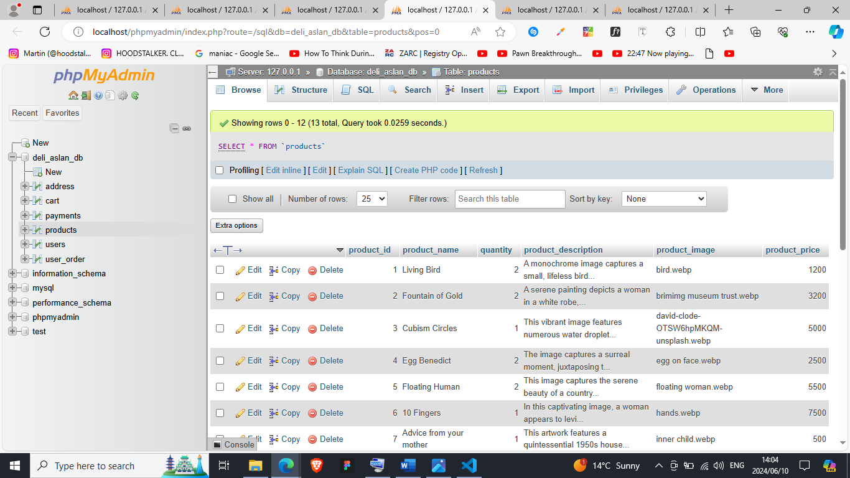

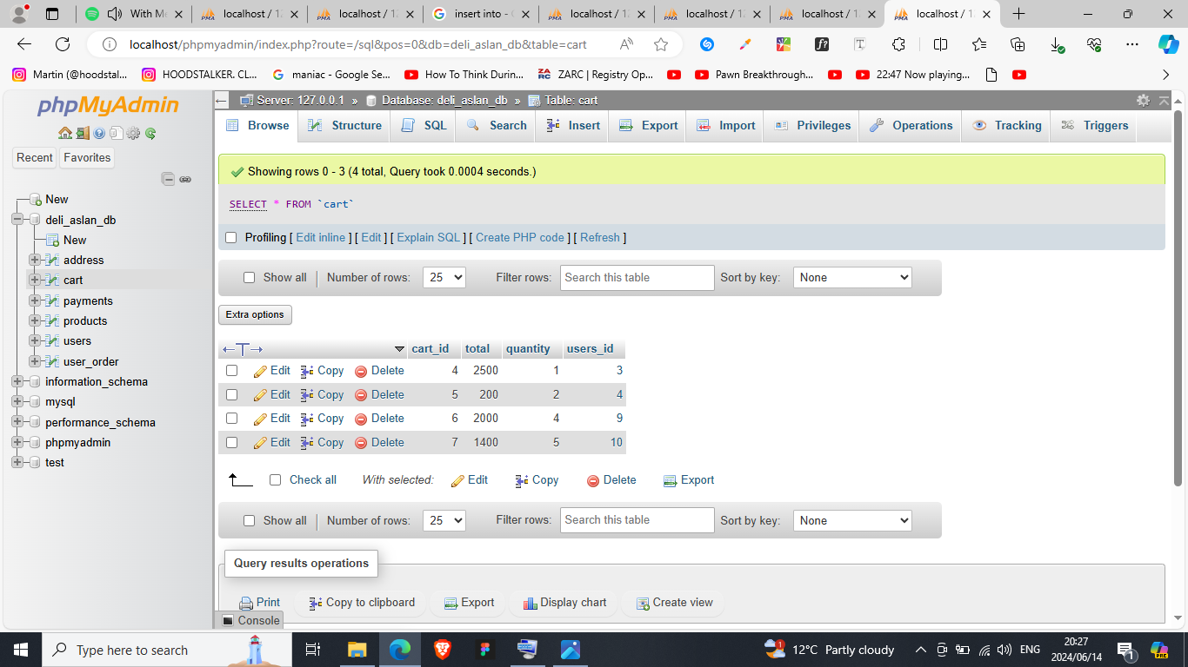

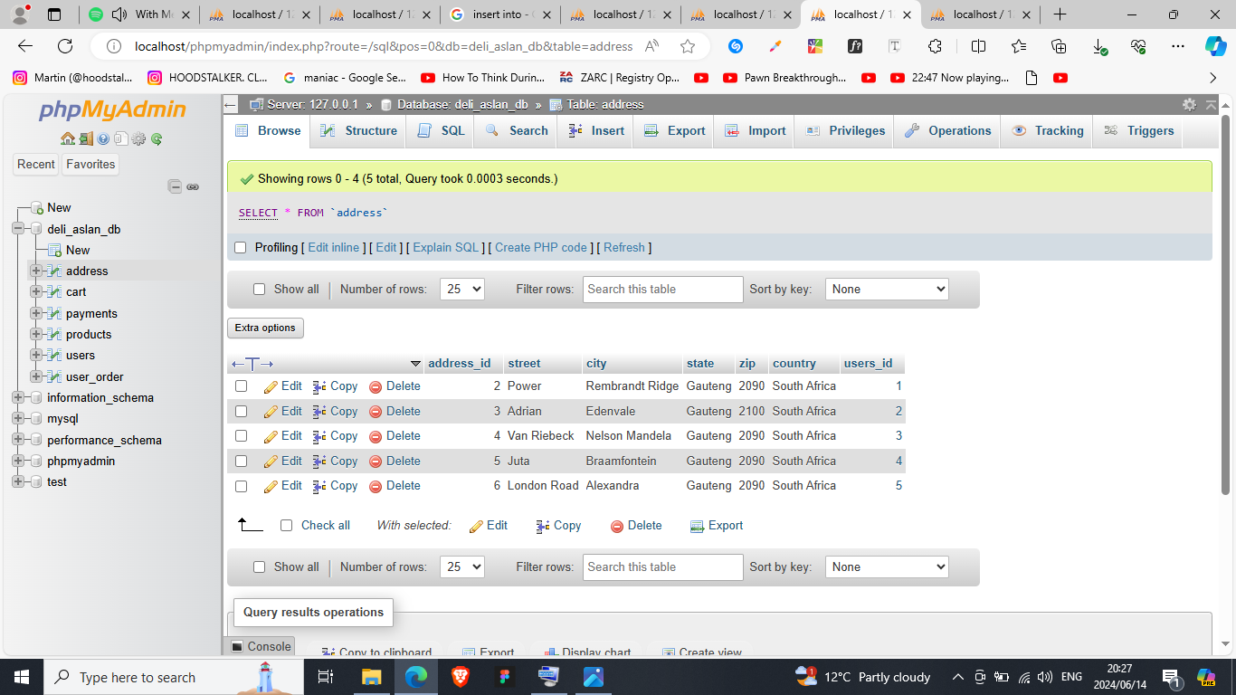

# Conclusion

The conclusion that I gathered from this assignment was that PHP is a powerful language with a range of exceptional features. This project empowered me to design, analyze, and develop a comprehensive e-commerce website, fostering hands-on experience with essential web technologies and client collaboration.

# Sign-off

|  |  |  |  |
| --- | --- | --- | --- |
|  |  |  |  |
| [Lukhanyo Ngxeke], Project Client  Date: 10 June 2024 |  |  | [Faith ], Project Manager  Date:10 June 2024 |

# Bibliography

1. www.youtube.com. (n.d.). Class Responsibility Collaborator (CRC) what is it and how to make it | easy explanation. [online] Available at: https://www.youtube.com/watch?v=TZYjPsQKU7w&t=60s [Accessed 29 Mar. 2024].
2. www.youtube.com. (n.d.). How to make crc (class responsibility collaborations) cards? explained with example. [online] Available at: https://www.youtube.com/watch?v=59tkQ-FwcpA&t=372s [Accessed 29 Mar. 2024].
3. ‌www.youtube.com. (n.d.). UML class diagrams. [online] Available at: https://www.youtube.com/watch?v=6XrL5jXmTwM&t=621s&pp=ygUPb2JqZWN0IGRpYWdyYW0g [Accessed 29 Mar. 2024].
4. Laudon, K. and Traver, C. 2020. E-Commerce 2020-2021: Business. Technology and Society, Global Edition, 16th Edition. Pearson UK.
   1. ISBN-13: 9781292343167
5. Nixon, R. 2021. Learning PHP, MySQL & JavaScript: With jQuery, CSS & HTML5. 6th edition. O’Reilly Media, Inc.ISBN: 9781492093824
6. MySQL. 2021. [Online] Available at: <https://www.youtube.com/watch?embed=no&v=7S_tz1z_5bA&t=27s>. [Accessed: 13 June 2024].
7. HTML, CSS and JavaScript Projects. 2021. [Online] Available at: <https://www.youtube.com/watch?embed=no&v=zAcdJC1GzBQ&list=PLNHtrE9aegUdAadBcyYFnvRcjBqOvrhuL>. [Accessed: 13 May 2024].
8. Learn JavaScript. 2021. [Online] Available at: <https://www.youtube.com/watch?embed=no&v=PkZNo7MFNFg>. [Accessed: 3 June 2024].
9. Web Development Full Course - 10 Hours | Learn Web Development from Scratch | Edureka. 2021. [Online] Available at: <https://www.youtube.com/watch?embed=no&v=Q33KBiDriJY&t=7785s>. [Accessed: 3 May 2024].
10. Complete Full Stack Website Development PHP. 2021. [Online] Available at: <https://www.youtube.com/watch?embed=no&v=jrYUUKh_lKg>. [Accessed: 13 June 2024].
11. Shop - The Art Spread. (n.d.). Retrieved June 14, 2024, from https://theartspread.org/shop
12. ‌Craig, W. (n.d.). 8 Ways to Add a Responsive Navigation Menu on Your Site. [online] WebFX. Available at: https://www.webfx.com/blog/web-design/responsive-menus/# [Accessed 14 Jun. 2024].
13. Envato Tuts+ (2017). JavaScript for Web Designers. [online] YouTube. Available at: https://www.youtube.com/watch?v=ResWVWI333o [Accessed 14 Jun. 2024].www.youtube.com. (n.d.).
14. www.youtube.com. (n.d.). 1 | Introduction to PHP Programming for Beginners | 2023 | Learn PHP Full Course for Beginners. [online] Available at: <https://www.youtube.com/watch?v=m52ljs78S24&list=PL0eyrZgxdwhwwQQZA79OzYwl5ewA7HQih>.
15. Nixon, R. 2015. Learning PHP, MySQL & JavaScript: With jQuery, CSS & HTML5. 4th Edition. O’Reilly Media, Sebastopol.ISBN: 978-1491918661
16. Campbell, B. and Darnell, R. 1997. Teach yourself dynamic HTML in a week. Indianapolis: SAMS.